**Report View**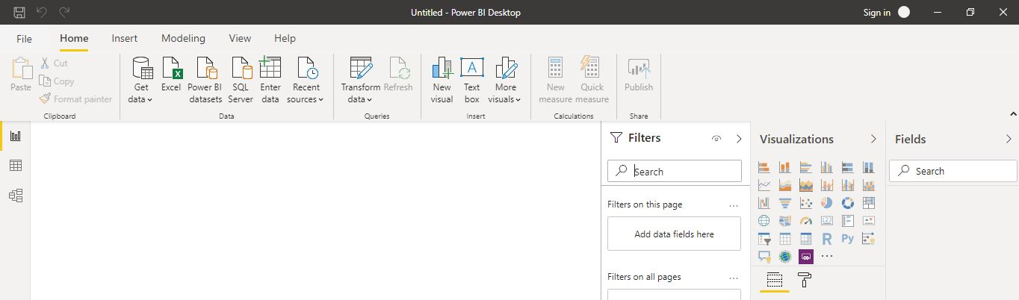

**Data View**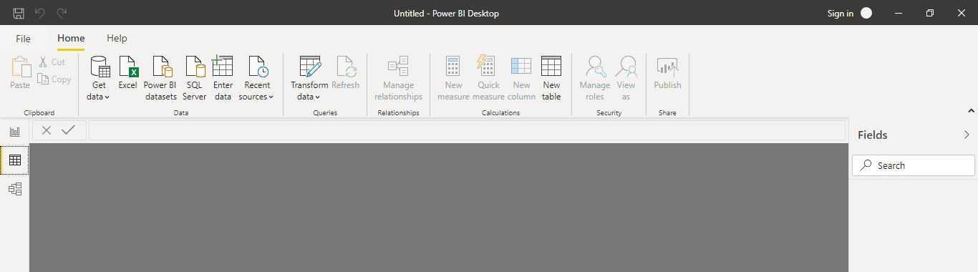

**Model View**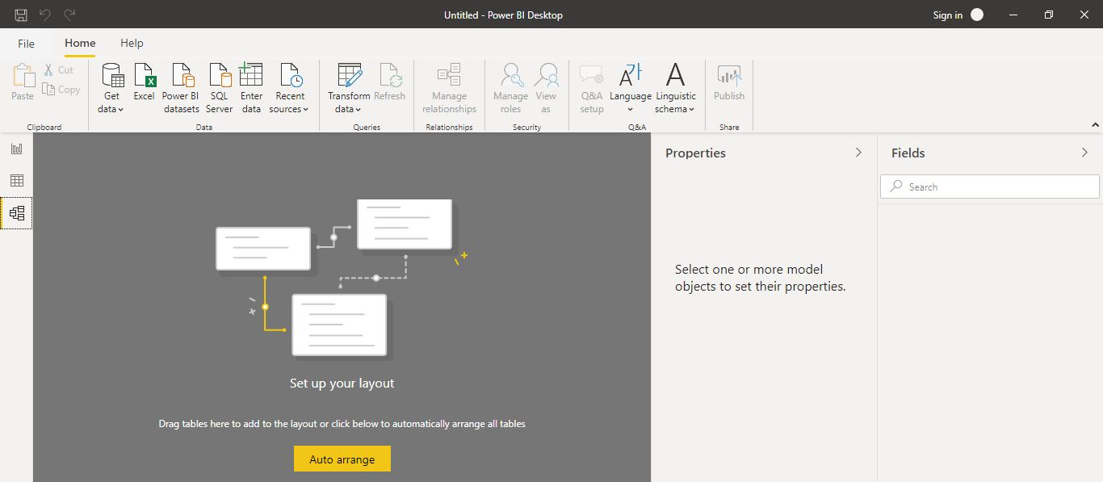

**Power Query Editor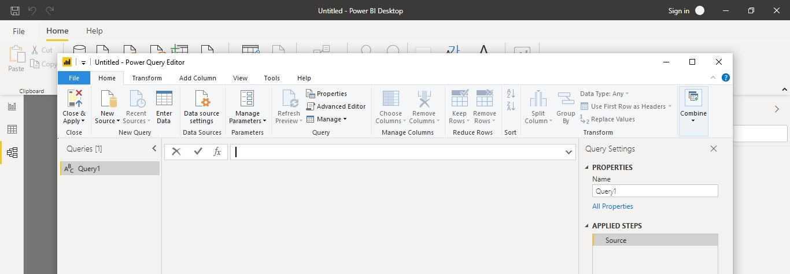Advance Editor**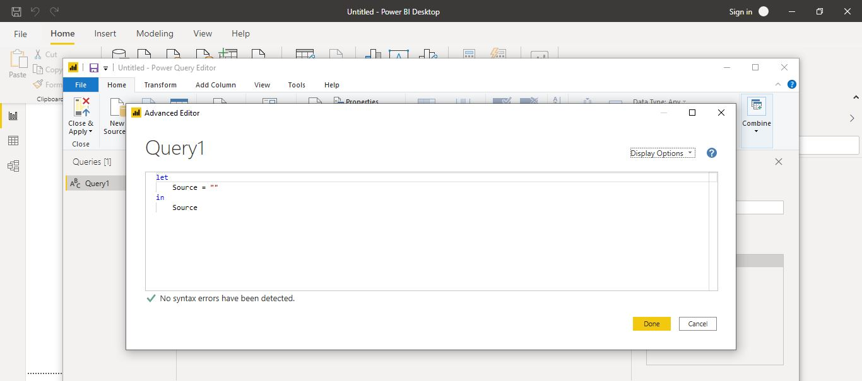

|  |  |  |
| --- | --- | --- |
| **Product** | **Amount** | **Extra information** |
| Power BI Desktop | Free |  |
| Power BI Pro | $9.99 | Amount is per month per user |
| Power BI Premium | $4,995 | Monthly price per dedicated cloud compute and storage resource with annual subscription |